Experiment: 18
HIGH LEVEL LANGUAGE EXTENSIONS – CURSORS

AIM
To implement Cursors using MySQL.
DESCRIPTION
CURSOR
A cursor is used to retrieve records one row at a time from a result set.
• Cursors process rows individually.
• They are mainly used inside stored procedures.
• Explicit cursors are declared and controlled by the programmer.
SYNTAX
DECLARE cursor_name CURSOR FOR
SELECT column_name FROM table_name;
OPEN cursor_name;
FETCH cursor_name INTO variable;
CLOSE cursor_name;

PROGRAMS AND OUTPUTS
Program – 1
Build a list of pet names using Cursor.
DELIMITER $$
CREATE PROCEDURE BuildPetList(INOUT pet_list VARCHAR(4000))
BEGIN
DECLARE finished INT DEFAULT 0;
DECLARE v_pet VARCHAR(50);
DECLARE pet_cursor CURSOR FOR
SELECT Pet_Name FROM Pet_Adoption;
DECLARE CONTINUE HANDLER
FOR NOT FOUND SET finished=1;
OPEN pet_cursor;
get_pet: LOOP
FETCH pet_cursor INTO v_pet;
IF finished=1 THEN
LEAVE get_pet;
END IF;
SET pet_list=CONCAT(v_pet, ';', pet_list);
END LOOP get_pet;
CLOSE pet_cursor;
END$$
DELIMITER ;
-- Execute the Cursor
SET @pet_list='';
CALL BuildPetList(@pet_list);
SELECT @pet_list;

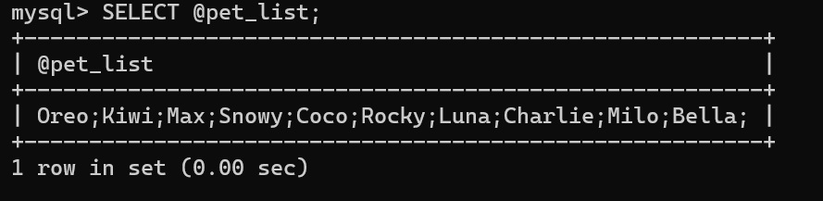
RESULT
Thus, the Cursor program using MySQL was executed successfully.

